

**American International University- Bangladesh**

**COE 3103: DATA COMMUNICATION**

**Final Lab Assignment**

**Spring 2021-2022**

**Section: I**

**Date: 21/04/2022**

**Submitted by,**

|  |  |
| --- | --- |
| Student Name | Student Id |
| Rahman, Sheikh Talha Jubayer | 19-41468-3 |

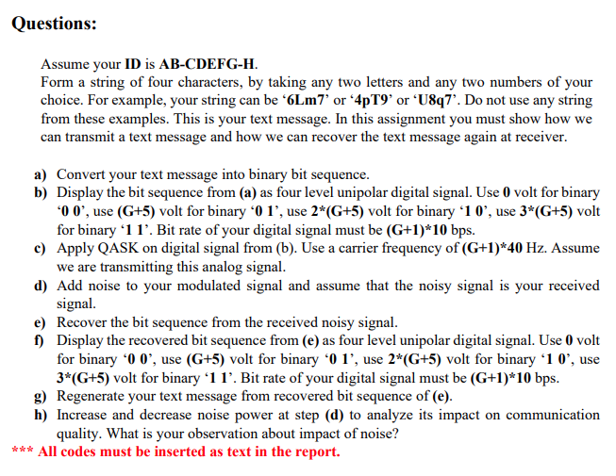

**Answer of the Questions**

%ID: 19-41468-3

A = 1;

b = 9;

C = 4;

D = 1;

E = 4;

F = 6;

G = 8;

H = 3;

am00 = 0;

am01 = (G+5); %(8+5) = 13

am10 = 2*(G+5); %2*(8+5) = 26

am11 = 3*(G+5); %3*(8+5) = 39

am = [am00 am01 am10 am11]; %amplitude for 4 level signal

cf = (G+1)*40; %carrier frequency = (8+1)*40 = 360 Hz

br = (G+1)*10; %bit rate = (8+1)*10 = 90

mbr = br/2; %modulated bit rate

mbp = 1/mbr; %modulated two bits period

txt = 'T2j9'; %message to transmit

%ans of (a) - convertion of text message into binary bit sequence

dec1 = double(txt); %text to ASCII (decimal)

p1 = 2.^(0:-1:-7); %2^0,2^-1,.......,2^-7

b1 = mod(floor(p1'*dec1),2); %decimal to binary conversion

bs = reshape(b1,1,numel(b1)); %bytes to serial conbversion

%end of ans of (a)

%ans of (b) - display of the bit sequence from (a)

ds = []; %digital signal of the bit sequence

for n=1:2:length(bs) %convertion of each two bits from the bit sequence to digital signal elements

if bs(n)==0 && bs(n+1)==0

rse = am(1)*ones(1,100);

elseif bs(n)==0 && bs(n+1)==1

rse = am(2)*ones(1,100);

elseif bs(n)==1 && bs(n+1)==0

rse = am(3)*ones(1,100);

else

rse = am(4)*ones(1,100);

end

ds = [ds rse];

end

t1 = mbp/100:mbp/100:100*(length(bs)/2)*(mbp/100); %time period for the digital signal

figure;

plot(t1,ds,'lineWidth',2.5);

ylabel('Amplitude');

xlabel('Time(s)');

title('Digital Signal of the Text Message');

grid on;

axis([ 0 mbp*(length(bs)/2) -5 45]);



%end of ans of (b)

%ans of (c) - apply QASK on digital signal from (b)

t2 = mbp/1000:mbp/1000:mbp; %time period for each signal elements

as = []; %modulated analog signal of the digital signal

for n=1:2:length(bs) %convertion of each two bits from the bit sequence to analog signal elements

if bs(n)==0 && bs(n+1)==0

y = am(1)*cos(2*pi*cf*t2);

elseif bs(n)==0 && bs(n+1)==1

y = am(2)*cos(2*pi*cf*t2);

elseif bs(n)==1 && bs(n+1)==0

y = am(3)*cos(2*pi*cf*t2);

else

y = am(4)*cos(2*pi*cf*t2);

end

as = [as y];

end

t3 = mbp/1000:mbp/1000:mbp*(length(bs)/2); %time period for the analog signal

figure;

plot(t3,as);

ylabel('Amplitude');

xlabel('Time(s)');

title('Modulated Analog Signal of the Text Message');

grid on;

axis([ 0 mbp*(length(bs)/2) -45 45]);



%end of ans (c)

%ans of (d) - add noice to the modulated signal from (c)

ras = awgn(as,5); %recieved noisy signal - add additive white gaussian noise

figure;

plot(t3,ras);

ylabel('Amplitude');

xlabel('Time(s)');

title('Recieved Analog Signal of the Text Message (SNR = 5)');

grid on;

axis([ 0 mbp*(length(bs)/2) -45 45]);



%end of ans (d)

%ans of (e) - recover bit sequence from the received noisy signal from (d)

rbs=[]; %recieved bit sequence of the noisy signal

for n=length(t2):length(t2):length(ras) %convertion of noisy signal elements to bit sequence

y = cos(2*pi*cf*t2); %carrier siignal

mm = y.*ras((n-(length(t2)-1)):n);

z = trapz(t2,mm);

zz = round((2*z/mbp));

if(zz<(am(1)+am(2))/2) %logic level, if the value is less than the middle point between the next amplitude

a = [0 0];

elseif(zz<(am(2)+am(3))/2)

a = [0 1];

elseif(zz<(am(3)+am(4))/2)

a = [1 0];

else

a = [1 1];

end

rbs=[rbs a];

end

%end of ans (e)

%ans of (f) - display of the recieved bit sequence from (e)

rds = []; %recieved digital signal of the bit sequence

for n=1:2:length(rbs) %convertion of each two bits from the recieved bit sequence to digital signal elements

if rbs(n)==0 && rbs(n+1)==0

rse = am(1)*ones(1,100);

elseif rbs(n)==0 && rbs(n+1)==1

rse = am(2)*ones(1,100);

elseif rbs(n)==1 && rbs(n+1)==0

rse = am(3)*ones(1,100);

else

rse = am(4)*ones(1,100);

end

rds = [rds rse];

end

figure;

plot(t1,rds,'lineWidth',2.5);

ylabel('Amplitude');

xlabel('Time(s)');

title('Digital Signal of the Recieved Bit Sequence');

grid on;

axis([ 0 mbp*(length(bs)/2) -5 45]);



%end of ans of (f)

%ans of (g) - convertion of recieved binary bit sequence into text message

l = length(rbs); %length of input string

l8 = 8*floor(l/8); %multiple of 8 length

b2 = reshape(rbs(1:l8),8,l8/8); %cols of b are bits of chars

p2 = 2.^(0:7); %power of 2

dec2 = p2*b2; %binary to decimal conversion

rtxt = char(dec2); %ASCII (decimal) to txt

Sent_Message = txt %output of sent message

Recieved_Message = rtxt %output of recieved message

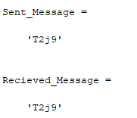

%end of ans of (g)

%ans of (h) - impact of noise change in (d)

% Increasing the noise of the channel or decreasing the SNR results on

% unusable received signal at the receiver point. Changing the SNR value of

% the code 5 to -45, change the sent message to a different message

% at the reciever point.

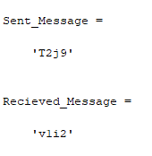

%end of ans (h)

**Full Code**

%ID: 19-41468-3

A = 1;

b = 9;

C = 4;

D = 1;

E = 4;

F = 6;

G = 8;

H = 3;

am00 = 0;

am01 = (G+5); %(8+5) = 13

am10 = 2*(G+5); %2*(8+5) = 26

am11 = 3*(G+5); %3*(8+5) = 39

am = [am00 am01 am10 am11]; %amplitude for 4 level signal

cf = (G+1)*40; %carrier frequency = (8+1)*40 = 360 Hz

br = (G+1)*10; %bit rate = (8+1)*10 = 90

mbr = br/2; %modulated bit rate

mbp = 1/mbr; %modulated two bits period

txt = 'T2j9'; %message to transmit

dec1 = double(txt); %text to ASCII (decimal)

p1 = 2.^(0:-1:-7); %2^0,2^-1,.......,2^-7

b1 = mod(floor(p1'*dec1),2); %decimal to binary conversion

bs = reshape(b1,1,numel(b1)); %bytes to serial conbversion

ds = []; %digital signal of the bit sequence

for n=1:2:length(bs) %convertion of each two bits from the bit sequence to digital signal elements

if bs(n)==0 && bs(n+1)==0

rse = am(1)*ones(1,100);

elseif bs(n)==0 && bs(n+1)==1

rse = am(2)*ones(1,100);

elseif bs(n)==1 && bs(n+1)==0

rse = am(3)*ones(1,100);

else

rse = am(4)*ones(1,100);

end

ds = [ds rse];

end

t1 = mbp/100:mbp/100:100*(length(bs)/2)*(mbp/100); %time period for the digital signal

figure;

plot(t1,ds,'lineWidth',2.5);

ylabel('Amplitude');

xlabel('Time(s)');

title('Digital Signal of the Text Message');

grid on;

axis([ 0 mbp*(length(bs)/2) -5 45]);

t2 = mbp/1000:mbp/1000:mbp; %time period for each signal elements

as = []; %modulated analog signal of the digital signal

for n=1:2:length(bs) %convertion of each two bits from the bit sequence to analog signal elements

if bs(n)==0 && bs(n+1)==0

y = am(1)*cos(2*pi*cf*t2);

elseif bs(n)==0 && bs(n+1)==1

y = am(2)*cos(2*pi*cf*t2);

elseif bs(n)==1 && bs(n+1)==0

y = am(3)*cos(2*pi*cf*t2);

else

y = am(4)*cos(2*pi*cf*t2);

end

as = [as y];

end

t3 = mbp/1000:mbp/1000:mbp*(length(bs)/2); %time period for the analog signal

figure;

plot(t3,as);

ylabel('Amplitude');

xlabel('Time(s)');

title('Modulated Analog Signal of the Text Message');

grid on;

axis([ 0 mbp*(length(bs)/2) -45 45]);

ras = awgn(as,5); %recieved noisy signal - add additive white gaussian noise

figure;

plot(t3,ras);

ylabel('Amplitude');

xlabel('Time(s)');

title('Recieved Analog Signal of the Text Message (SNR = 5)');

grid on;

axis([ 0 mbp*(length(bs)/2) -45 45]);

rbs=[]; %recieved bit sequence of the noisy signal

for n=length(t2):length(t2):length(ras) %convertion of noisy signal elements to bit sequence

y = cos(2*pi*cf*t2); %carrier siignal

mm = y.*ras((n-(length(t2)-1)):n);

z = trapz(t2,mm);

zz = round((2*z/mbp));

if(zz<(am(1)+am(2))/2) %logic level, if the value is less than the middle point between the next amplitude

a = [0 0];

elseif(zz<(am(2)+am(3))/2)

a = [0 1];

elseif(zz<(am(3)+am(4))/2)

a = [1 0];

else

a = [1 1];

end

rbs=[rbs a];

end

rds = []; %recieved digital signal of the bit sequence

for n=1:2:length(rbs) %convertion of each two bits from the recieved bit sequence to digital signal elements

if rbs(n)==0 && rbs(n+1)==0

rse = am(1)*ones(1,100);

elseif rbs(n)==0 && rbs(n+1)==1

rse = am(2)*ones(1,100);

elseif rbs(n)==1 && rbs(n+1)==0

rse = am(3)*ones(1,100);

else

rse = am(4)*ones(1,100);

end

rds = [rds rse];

end

figure;

plot(t1,rds,'lineWidth',2.5);

ylabel('Amplitude');

xlabel('Time(s)');

title('Digital Signal of the Recieved Bit Sequence');

grid on;

axis([ 0 mbp*(length(bs)/2) -5 45]);

l = length(rbs); %length of input string

l8 = 8*floor(l/8); %multiple of 8 length

b2 = reshape(rbs(1:l8),8,l8/8); %cols of d are bits of chars

p2 = 2.^(0:7); %power of 2

dec2 = p2*b2; %binary to decimal conversion

rtxt = char(dec2); %ASCII (decimal) to txt

Sent_Message = txt %output of sent message

Recieved_Message = rtxt %output of recieved message